SHAH SATNAM JI GIRLS’ SCHOOL, SIRSA

RESULT CLASS-XII (SESSION 2023-24)

Total Students : | 173
Pass : | 100%
Merits : | 119
90% & Above : | 46
80% to 89% : | 73
75% to 79% : | 22
1st Division : | 31
2nd Divison : | 01

Our Toppers

Position | Name | Marks | Percentage | Photo
1st | Ridhima | 487 | 97.4% | 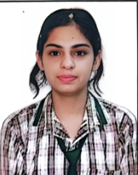
2nd | Navdeep Kaur | 485 | 97% | 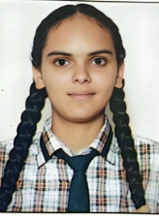
3rd | Kalpna | 484 | 96.8% | 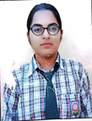

Subject wise Highest Marks

Accountancy | - | 100
Pol Science | - | 100
Music Vocal | - | 100
Music Instrumental | - | 100
Punjabi | - | 100
Geography | - | 99
English | - | 98
Business Studies | - | 98
History | - | 98
Computer Science | - | 98
Mathematics | - | 98
Economics | - | 97
Physical Education | - | 97
Chemistry | - | 95
Physics | - | 95
Biology | - | 95
Psychology | - | 95
Hindi | - | 94

SHAH SATNAM JI GIRLS’ SCHOOL, SIRSA

RESULT CLASS X SESSION 2023-24

Total Students : | 170
Pass : | 100%
Merits : | 83
90% & Above : | 36
80% to 89% : | 47
75% to 79% : | 28
1st Division : | 48
2nd Division : | 11

Subject wise Highest Marks

Computer : | 100
Punjabi : | 100
S.st : | 100
English : | 99
Science : | 99
Mathematics : | 98
Hindi : | 95

Our Toppers

Position | Name | Marks | Percentage | Photo
1st | Vandita | 493 | 98.6% | 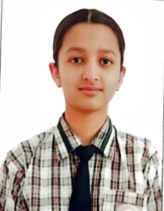
2nd | Suruchi | 478 | 95.6% | 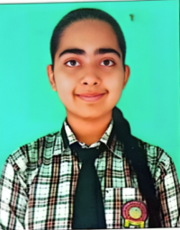
2nd | Gunjan | 478 | 95. 6% | 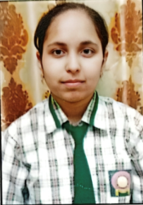
2nd | Vanshbhej | 478 | 95.6% | 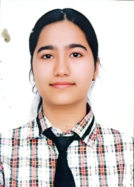
3rd | Parul | 476 | 95.2% | 