SHAH SATNAM JI GIRLS’ SCHOOL, SIRSA

RESULT CLASS-XII (SESSION 2024-25)

Total Students : | 158
Pass : | 100%
Merits : | 97
90% & Above : | 30
80% to 89% : | 67
75% to 79% : | 33
1st Division : | 27
2nd Divison : | 01

Our Toppers

Position | Name | Marks | Percentage | Photo
1st | Priyanshi (Commerce) | 494 | 98.8% | 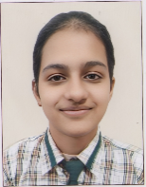
2nd | Gurnaaz Sidhu (Arts) | 486 | 97.2% | 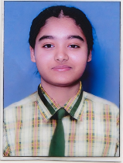
3rd | Ishitaa Mittal (Arts) | 485 | 97% | 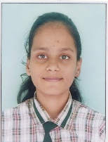
3rd | Satuti (Non-Medical) | 484 | 96.8% | 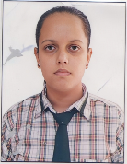

Subject wise Highest Marks

Music Vocal : 100 (10)
Computer Science : 100
Psychology : 100
Accountancy : 100
English Core : 99
Mathematics : 99
Economics : 99
Music Instrumental : 99
Punjabi : 99
Business Studies : 98
Political Science : 98
Chemistry : 97
Geography : 97
History : 97
Phy Education : 97
Hindi Core : 96
Physics : 95
Biology : 95

SHAH SATNAM JI GIRLS’ SCHOOL, SIRSA

RESULT CLASS-X (SESSION 2024-25)

Total Students : 202
Pass : 100%
Merits : 68

90% & Above : 16
80% to 89% : 52
75% to 79% : 27
Ist Division : 83
2nd Division : 21
3rd Division : 03

Our Toppers

Position | Name | Marks | Percentage | Photo
1st | Jaismeen Dhaliwal | 491 | 98.2% | 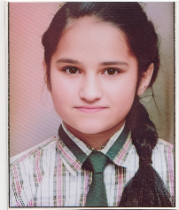
2nd | Ujjwal | 482 | 96.4% | 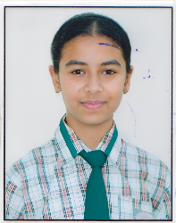
3rd | Alish | 481 | 96.2% | 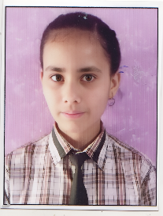

Subject wise Highest Marks

Computer : 100 (6)
Punjabi : 100 (1)
Mathematics : 99
Social Science : 99
Science : 98
Hindi : 95
English : 91

