SHAH SATNAM JI GIRLS’ SCHOOL, SIRSA

RESULT CLASS- XII (SESSION 2025-26)

Total Students : | 174
Pass : | 100%
Merits : | 111
95% & Above : | 12

90% & Above
: | 39
: | 60
: | 23
: | 38
: | 02

80% to 89%
75% to 79%

Ist Division 2nd Divison

Overall Toppers

Position | Name | Stream | Marks | Percentage
1st | Vandita Kaswan  2nd in India  Ist in Haryana | Arts | 498 | 99.6% | 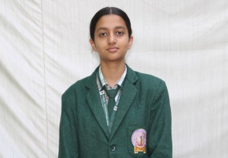
2nd | Ritika  3rd in India  2nd in Haryana | Arts | 497 | 99.4 % | 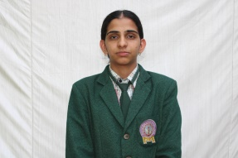
3rd | Priya | Arts | 490 | 98% | 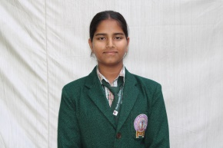

Arts Toppers

Position | Name | Marks | Percentage
1st | Vandita Kaswan (Arts) 1st in Haryana &  2nd in India ) | 498 | 99.6%
2nd | Ritika (Arts) | 497 | 99.4 %
3rd | Priya (Arts) | 490 | 98%
Commerce Toppers

Position | Name | Marks | Percentage
1st | Jaismeen kaur | 481 | 96.2%
2nd | Anshreet Insan | 476 | 95.2%
3rd | Kirti | 468 | 93.6%
Science Toppers

Position | Name | Marks | Percentage
1st | Gunjan (N.med) | 466 | 93.2%
1st | Pratigya (N.med) | 466 | 93.2%
1st | Khushi (Med.) | 466 | 93.2%
2nd | Vanshbhej (Med.) | 463 | 92.6
3rd | Suruchi (Med.) | 462 | 92.4

Subject –wise Summary

Painting | - 100 (6)
Music Instrument | - 100 (5)
Psychology | - 100 (2)
Pol Science | - 100 (2)
Geography | - 100
Economics | - 100
History | - 100
Music Vocal | - 100
English | - 99 (2)
Punjabi | - 99
Business Studies | - 99
Physical Education - 99
Hindi Core | - 98
Biology | - 97
Accounts | - 93
Physics | - 90
Mathematics | - 90
Chemistry | - 88

SHAH SATNAM JI GIRLS’ SCHOOL, SIRSA

RESULT CLASS-X (SESSION 2025-26)

Total Students : 161
Pass : 100%
Merits : 112
90% & Above : 54
80% to 89% : 58
75% to 79% : 23
Ist Division : 26
Toppers
Position | Name | Marks | Percentage | Photo
1st | Anandita Makkar vuafnrk eDdj | 491 | 98.2% | 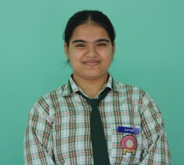
2nd | Khushi [kq”kh | 480 | 96 % | 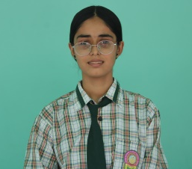
3rd | Amanat Insan vekur balk | 479 | 95.8% | 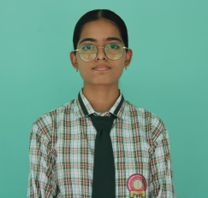

Subject wise Highest Marks

Computer : 100 (10)
Painting : 100 (1)
Punjabi : 100 (1)
English : 98
Hindi : 98
S.st : 98
Science : 95
Mathematics : 91

